Class Sessions #5
15 October 2019
Copyright: Ronald B. Mitchell, 2019

Determinants of Affluence Growth

Discussion

What are the determinants?

Why is it so hard to change?

How does it relate to CO2 emissions?

Environmental Kuznets curve

Graph of the relationship between increasing affluence (income: GDP per capita) and pollution levels

What do you expect it to be?

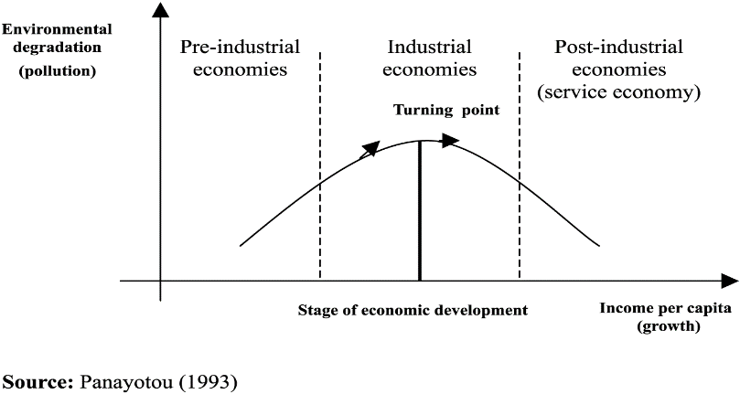

Logic

As people get richer, three competing things happen:

People have more money and so buy more stuff and so pollution/emissions increase

But, after a certain point, this is more than offset by the fact that as people have more money, they start caring more about the environment and demand government protection of it

And, more money correlates with service economy which “displaces” or “offshores” the pollution

Changing Affluence Growth

Some policies do influence consumption patterns

Buddhist monks

Jewish observance of Shabbat

Mormon tithing

Voluntary simplicity: “frugality of consumption”

So do social norms

“More, More, More said the baby.”

“I want a better life for my kids.”

“I need a raise.”

“I need a vacation.”

Yet affluence also appears “off limits” politically (though see “Confronting Consumption”)

Determinants of Technology growth

Discussion

What are the determinants?

Why is it so hard to change?

How does it relate to CO2 emissions?

Changing Technology: Rebound and the Jevons Paradox

Jevons Paradox: technological progress that increases efficiency of a resource being used leads to MORE of that resource being used. “Technological improvements that increased the efficiency of coal-use led to the increased consumption of coal [and therefore] could not be relied upon to reduce fuel consumption” (Wikipedia)

York (UO Sociology Prof) showed in most countries for past 50 years, each unit of nonfossil-fuel energy displaced less than ¼ unit of fossil-fuel energy and each unit of nonfossil-fuel electricity displaced less than 1/10th” (York 2013).

As technology becomes more efficient, the price of that technology declines and two competing things happen.

Pollution per unit goes down

Number of units used goes up, because they are cheaper

York’s point is that: We might expect people to shift to renewables but actually, it lowers the overall prices of energy and we end

Changing Behavior: How Hard Can It Be?

If I told you I had a new technology that could increase your car’s fuel efficiency by 20% and reduce your CO2 emissions by 20%, would you use it?

How much would you pay for it?

It’s the gas pedal

Most people drive 75 mph on freeways

Slowing to 65 mph decreases emissions by ~10%

Slowing to 55 mph decreases emissions by ~20%

No law is required!

Which of these drivers are we addressing?

We are not addressing two of the drivers

Population - No

Affluence - No

Technology – Yes

I don’t think improving technology alone can get us there

Can we invent new technology?

If we do, can we get people to use it?

Population and affluence: the role of government

Population and affluence reflect deep-seated values

Democracies usually see values as inputs to government policy not targets of government policy

Democracies tend NOT to see “shaping values” as an appropriate role for government

Population and affluence: alternatives to government

Many people DO see “shaping values” as an appropriate role for other institutions

Religions

Families

Corporations

Social movements

Conscious communities

