Class Session #15
19 November 2019
Copyright: Ronald B. Mitchell, 2019

Discussion of final paper

Thinking Theoretically about Climate Change Negotiations

What are the characteristics of the problem?

Type & strength of actor motivations to address it?

Negotiation Theory overview

Type of agreement

Terms of agreement

Three elements of Regulatory System

Type & strength of actor motivations to address it?

Unilateral interest-based

Interdependent interest-based

Normative-based

BATNA (Best Alternative to a Negotiated Agreement)
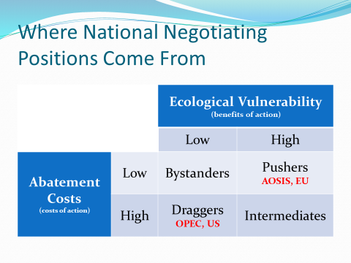

Negotiation Theory Overview

ZOPA (Zone Of Possible Agreement)

Finding the existing ZOPA

Interests as exogenously “given”

Can’t do more than countries involved want to do

Creating a new ZOPA

Interests as endogenously created

Leadership

Argument and persuasion

Bringing external pressure to bear

Engaging NGO community

Creating deadlines and expectations

Ensuring agreement but also follow through

Type of Agreement

Type of obligations

Top-down (imposed commitments)

Bottom up (voluntary commitments)

Level of ambition/stringency

Breadth of membership: Universal or Climate club

Legal status: Binding or non-binding

Terms of agreement

Substantive topic areas

Mitigation

Adaptation

Loss and Damage

Three elements of Regulatory System

Primary rule system

Mitigation Obligations

Financial Mechanisms

Information system

Response system

Lead-in to the Paris Climate Negotiations

Video: International Climate Governance

Paris Agreement, Where we are, and Where we need to be

Graphic

How Paris was negotiated: Background mattered

“By the opening of the Paris conference, 186 governments had declared national plans covering 94 percent of global emissions (UNFCCC 2015b). These policy pledges laid an important foundation for a global UN agreement” (Dimitrov, 2016).

2014 US/China agreement on climate emission reductions

How Paris was negotiated: Process mattered

“Social learning” from previous experience (failures and successes)

French leadership of negotiations and use of various tactics to foster agreement

Framing issues in certain ways

How Paris was negotiated: Secrecy and few actors

All states present at Paris but Paris Agreement reflects “heavy use of secrecy. … [Key issues] were resolved in Paris in secret meetings among a few countries. … The value of secrecy was in reducing the number of actors” (Dimitrov, 2016).

How Paris was negotiated: Paper over differences

“‘Developed country Parties shall provide financial resources to assist developing countries” while “other Parties are encouraged’ to provide such support voluntarily (Art. 9). … After entry into force, Parties shall set a new collective financial goal ‘from a floor of USD 100 billion per year’ (para. 54)” (Dimitrov, 2016).

Legal Status: Why Paris is NON-binding

“If we insist on legally binding, the deal will not be global because we will lose the US” (top EU official). In the end, it was the US that weakened mitigation commitments for developed countries in the new agreement. Literally in the last minutes before the final session that adopted the agreement on December 12, the US demanded a single word change: Developed countries “should” rather than “shall” undertake economy-wide quantified emission reductions” (Dimitrov, 2016).

Level of ambition/stringency: Why Paris has weak goals

Goal: Most states wanted 1.5°C goal: “It was politically inexpedient to oppose publicly 1.5°C. Hence, industrialized countries engaged in a political exercise of linguistic gymnastics: how to craft ‘creative language’ that mentions 1.5 °C without making it the official operational goal” (Dimitrov, 2016).

Commitments: “The weaknesses of the agreement and a lack of political commitment may undermine its environmental effectiveness The aggregate effect of current national pledges is expected to be a global mean temperature rise of 3.7–4.8 degrees this century (UNFCCC 2015b, 8)” (Dimitrov, 2016).

Monitoring and Compliance: Why Paris has weak follow through

Global “stocktake” every five years

“Compliance mechanisms are weak, with a ‘facilitative’ committee whose work is ‘non-adversarial and non-punitive’ (Art. 15)” (Dimitrov, 2016).

Loss and Damage: Why Paris is not fair

… “important to many countries who hold the North historically responsible for negative climate impacts. Island states wanted an institutional process to address permanent loss and irreversible damage. All developed countries closed ranks, strongly united against provisions that could lead to liability and compensation, and blocked the creation of institutional arrangements. In closed consultations, rich countries carefully strategized to formulate text that gives nominal recognition to the issue, while precluding legal obligations” (Dimitrov, 2016).

Ratification and Implementation

Ratification process explained

Executives sign agreement

Then Legislatures ratify them

All memberships are voluntary

Implementation matters too

What happens if states don’t meet their commitments?

But is it meaningless?

It may have some instrumental influence

AND

The power of norms may matter

