Lecture #6

11 October 2018
Copyright: Ronald B. Mitchell, 2018

Introduction

Apply problem structure to real-world problems

Crucial point: Identifying a problem’s problem structure: COMPARING is easiest way to classify real-world problem structures. Easier to say “issue area A is more transparent than issue area B” than to say “issue area A is transparent”

Basic understanding of the problem structures of free trade

Protectionism: government policies that reduce the flow of goods (or services) from one country to another by:

Tariffs – taxes on imports that increase the price of foreign goods above the price of domestically-produced goods and, therefore, remove the economic incentives for anyone to import them

Subsidies – payments to domestic producers of a good that lower the costs they need to charge to make a profit so that, at market, their prices are lower which (like a tariff) removes the economic incentives for anyone to import the same good from another country

Quotas – government limits on the quantity of imports that prevent somebody from importing goods that they would otherwise have incentives to import

Non-tariff barriers (NTBs) – government rules that prevent goods made in certain ways or that include certain components from being imported from other countries.

Free trade: absence of protectionism

How protectionism works
 | Actual cost | Subsidy | Tariffs | Cost at market
US producers | $0.36 | $0.12 | -- | $0.24
Mexican producers | $0.20 | -- | -- | $0.20
Non-Mexican producers | $0.15 | -- | $0.10 | $0.25

Benefits of free trade and costs of protectionism

Lower costs of goods to consumers – necessarily true (goods won’t be imported if they cost more than local goods)

Increased amount of goods because of specialization (more efficient use of resources)

Export sector growth: more jobs in those sectors in which countries have comparative economic advantage. Jobs and wages of those in competitive industries grow relative to prior levels.

Economies are larger and grow faster with free trade than without

Costs of free trade and benefits of protectionism

Local industries that are not competitive (import-competing sector) will die out, and those workers will lose jobs, if not retrained. Wages of those in few companies that survive in previously-protected import-competing sectors decline as well.

Loss of local market diversity – each country focuses economic activities in those realms it does best in

Production of more stuff has environmental impacts

Interactions among three sectors explain why there is protectionism

Import-competing sector

Export sector

Consumers
 | Trade
Q1: Conflict/harmony/cooperation Do states see non-cooperation as suboptimal? | Conflict with potential for cooperation  Trade wars: domestic political incentives to raise tariffs to protect import-competing sector lead to slower economic growth of country’s economy as a whole.  States see opportunities for better outcomes.
Q2: Actors | All countries involved, though trading partners and neighbors matter more than others  Governments of powerful states  Import-competing sector companies  Export sector companies, often including multinationals  Consumers  Politicians
Q3: Capacities/power | All states can impose tariffs, subsidies, quotas, NTBs  Some countries have significant power through market attractiveness and competitiveness of products
Q4: Incentives/preferences  (when capacity issues not in play) | Collaboration game  Standard Tragedy of the Commons or Prisoners’ Dilemma  How do we know? Incentives to cheat even after rules agreed to!  Distribution problem can be left to the market  Domestic pressure for protection from import-competing sector  Opposing pressure from export sector  Ag sector succeeds more than manufacturing
Q5: Information/knowledge | Trade does not have any serious knowledge or information problems. We generally understand how it works.  Most states believe free trade grows economy – theory supports free trade (but this is a recent idea)
Q6: Norms/values | No morality of high v. low tariffs  But some have norm against free trade: “Buy American”  Norms play a role in NTBs that they don’t play in other policies
Q7: Transparency/ability to cheat | Tariffs, quotas, non-tariff barriers (NTBs) “visible at the border”  Subsidies NOT visible at border
Q8: Response incentives | Can target response: ability to target and calibrate response  Incentives to calibrate response to maintain broader agreement  Quite violation tolerant because can be “undone”  Enforcement problem is resolvable  Reputational concerns

Major successes in cooperation to overcome the problem

GATT/WTO: Significant progress in lowering trade barriers over time
Graph I: Trade as a Percent of GDP. Graph II: Tariffs on International Trade.
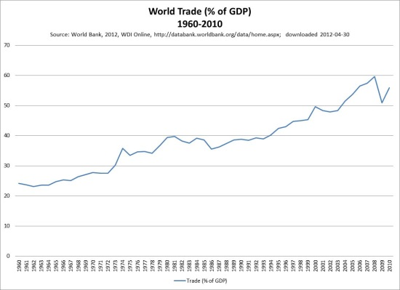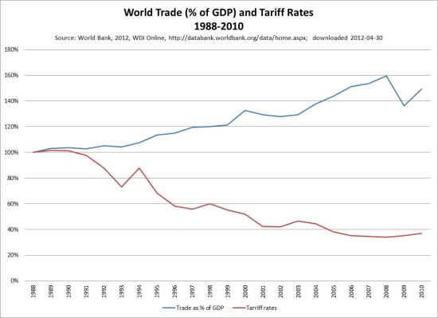

The European Union

Removed all trade barriers and number of countries has grown significantly.

Economies of all have grown quickly

Stabilized countries via monetary cooperation

Has managed free trade to reduce more harmful impacts of on environment

How do we explain strong success in forming international institutions in much of international trade

Growing economies is important goal of countries

At least some powerful economic interests support free trade (export sector companies)

Incapacity is not a problem

Lack of knowledge is not a problem or reason for inaction

Distribution problem can be left for the market to resolve (perhaps surprisingly)

Strong normative agreement that growing economies is good – very few people question this

Most protectionist policies are inherently transparent

Strong incentives to undertake enforcement actions, since coincides with interests of import-competing sector

Complete failure in reducing agricultural subsidies however. Why?

US spends about $20 billion per year on agricultural subsidies to American farmers. These subsidies aid American farmers but at the cost of farmers in developing countries that could grow the same product more cheaply and export it to the US

EU spends about $60 billion per year on the Common Agricultural Policy of subsidies and price supports.

GATT/WTO have never reduced ag subsidies

Why is there free trade in manufacturing but not in agriculture?

“Powerful” states (i.e. US and other advanced nations) have a comparative advantage in manufacturing and a comparative disadvantage in agriculture. So, they have a greater interest in protecting agriculture than in protecting industry, and this affects what is possible at the international level.

Agricultural interests are over-represented in some key countries (e.g. the US) due to institutions like the US Senate that give more weight to rural areas.

The public is afraid of food imports due to concerns about “food security”, health (e.g. fears about importing beef from countries with mad cow disease), etc.

Conclusion

Identifying real-world variation in problem structure

Value of COMPARING problem structure of different issue areas in a relative way or on a relative scale. Much harder (ineed, TOO hard) to assess problem structure in an absolute way or absolute scale.

