Lecture #14
8 November 2018
Copyright: Ronald B. Mitchell, 2018

Effectiveness overview

Why and under what conditions do nations change their behavior in response to regimes? Cannot assume compliance is same as treaty-induced compliance.

Terminology

Implementation - passing domestic legislation for legal conformity with rules

Compliance - behavior on the ground that conforms to rules

Monitoring, verification, & transparency - determining whether actors are complying.

Enforcement - process by which those with incentives to not comply are induced to do so.

Effectiveness - two major ways to think about it:

Institutional influence
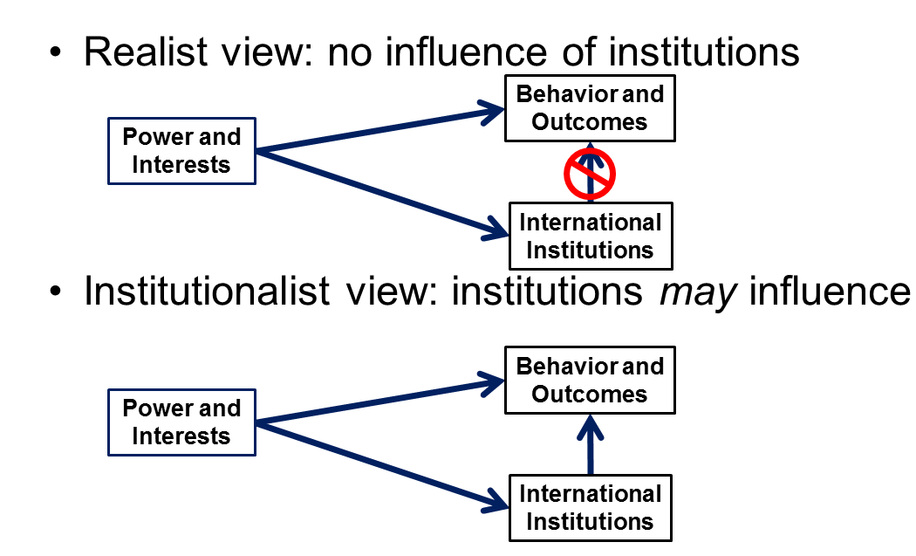

Enforcement school

Logic of consequences is central

Compliance expectation

High compliance

Low treaty-induced compliance -- its all coincidental compliance

Unlikely to influence any states but members

Why and when do states comply?

Voluntariness of international institutions:

Countries that become members of a treaty are those that already planned on changing behavior as required

Members differ from non-members in terms of "willingness to comply"

Shallow cooperation: not much is required of them

Collaboration games

Changes in behaviors that are already planned

States sign agreements to ratify already planned decreases.

"Remarkable compatibility [of nuclear obligations states accept & their planned] strategic nuclear weapons programs" (Goldblat in Downs, Rocke and Barsoom in SM, 290).

"The Montreal Protocol was enacted because it codified reductions in CFC emissions that polluters were voluntarily prepared to accomplish" (Barrett in DRB in SM, 291).

Why and when do states violate?

Whenever it is in their short-term interests to do so

Violate rules, i.e., don't change their behavior, if it isn't in their short-term interests

Violations reflect a very deliberate calculation of interests, using a logic of consequences

Violate with little regard to legal requirements and norms

Intention: Violate because:

Disagree that there is a problem that deserves collective action

Agree there is a problem but want to "free-ride" on contributions of others

Want to overturn institutional rules and norms: behave contrary to normative rules in order to undermine and weaken them. Disagree with norm and roles and want to re-construct new norms and roles more to their liking. E.g.: Norway and Iceland violations of whaling regime to demonstrate their belief that whaling is morally okay

Management school

Logic of appropriateness is important but logic of consequences ALSO plays a role

Compliance expectation

Hard to tell about compliance levels because terms are often so vague

High compliance, if one can tell

High treaty-induced compliance, at least if institution properly designed

May even influence non-members

Why and when do states comply?

Because they are in their interests

Pacta sunt servanda - general norm that, if you sign a treaty voluntarily, you should do what you said you would

States don't continuously recalculate their interests -- once states decide to comply, they don't constantly re-evaluate whether it’s a good idea (this is Chayes and Chayes "efficiency" argument - it is "efficient" to comply in terms of making decisions)

Habit of complying

Whenever enough other states are complying so there is "critical mass" if benefits of compliance by others outweighs costs to you of contributing, then comply -- assumes that states believe others' behaviors are contingent on theirs and will take risks to avoid problems due to that

Expectations and normative pressure from other states and within own state: voluntarily agreed to comply, so you should, say other countries and your own polity

Why and when do states violate?

Not very often

Ambiguity of treaties leads violating state to interpret it in a way that others view as violations

Incapacity: Lack capacity to comply: scientific, technical, bureaucratic, and financial

Inadvertence: Try to comply but fail because of inadvertence or changes in economic or social circumstances

Only violate after careful consideration of treaty requirements

Institutions can always be evaluated against TWO definitions of success

Goal achievement: Compare actual behavior (or outcomes) to stated goal

Was goal of treaty achieved ("how far from full is the glass?")

Counterfactual: Compare actual behavior (or outcomes) to what would have occurred otherwise

Is problem improved compared to no treaty? ("how far from empty is the glass?")

Human Rights Example

Hypothetical example

Real Example: Education of Women under CEDAW

How do we generate a convincing counterfactual?????

Members before to members after

Members to non-members after

Members to non-members before and after

Members regulated vs. non-regulated behavior

Effectiveness of institutions

Where to look: How do we observe the effects of a treaty - what are the proper metrics or indicators of effects?

How to look: How do we identify the "counterfactual" of the world without the treaty, or with the treaty but without the particular feature of the treaty (e.g., financial incentives)?

Compare after to before for member countries

Compare members to non-members after

Compare regulated behavior of members to non-regulated behavior of members

Is there a difference? What were the effects of each treaty?

COUNTERFACTUAL: counterfactual is the estimate (based on available evidence) of what would have happened without an agreement (or other causal factor) that is used to evaluate the argument regarding whether the agreement made a difference. If the line you generate as your counterfactual line is identical to your "observed data" line, then your argument must be that the agreement did not make a difference. Note that a counterfactual is therefore simply part (a usually implicit part) of the same theory you are evaluating. Thus, the argument that "this treaty made a difference" is supported by building an argument that the counterfactual line looks different than the line we actually observed.

Is difference due to treaty? What other factors might have caused changes?

ALTERNATIVE EXPLANATION or RIVAL HYPOTHESIS: an "alternative explanation" or "rival hypothesis" is NOT the same as a counterfactual. An alternative explanation (or rival hypothesis, they mean the same thing) is an argument that takes the form of "no, it’s not the treaty that made the difference but something else." For example, an alternative explanation of a treaty on landmines might argue that "yes, there is a reduction in the number of landmines being used by the countries of the world, and it did occur after the landmines treaty was signed BUT that reduction in landmine use is NOT due to the landmine treaty but is due to the fact that technology advanced so that it was more effective to use hand grenades rather than landmines." You address an alternative explanation by saying, "well, some people would say that the decline in landmines is due to the availability of very sophisticated hand grenades which were cheaper anyway, and so it was the availability of a lower cost alternative to landmines rather than a treaty banning them that explains the decline in landmine use. HOWEVER, this argument is wrong because in the ten years since the landmine treaty was signed, handgrenades have been even more expensive than they were before whereas landmines have gotten even cheaper than they were before. So, this alternative explanation is false."

What was the problem structure that the Montreal Protocol was addressing? Did that dictate the terms of the regime as well as any behavioral change that occurred?

Were there any economic downturns or development of cheaper alternatives that might explain the change in behavior?

Were there any changes in political pressures that might have led to changes in behavior even without the treaty adopting financial incentives?

Is the difference impressive? Was it an easy problem or a hard problem to resolve?

Effectiveness variation due to Problem Structure

Problem structure: “Characteristics of activity involved” from Brown Weiss and Jacobson

Fewer actors – more effective {Jacobson, 1998 #3970, 521}.

Economic incentives foster (rather than hinder) regulation – more effective {Jacobson, 1998 #3970, 521}.

Multinationals play big role in activity – more effective {Jacobson, 1998 #3970, 522}.

Concentration of activity in major countries – more effective {Jacobson, 1998 #3970, 523}.

General claims in context of course

Institutions facing HARDER problems are likely to be less effective

Easy group:

COORDINATION problems – should be quite effective

Big effect but not particularly impressive

“Shallow cooperation” in Downs, Rocke, Barsoom’s terminology

EPISTEMIC problems: pooling resources but they are informational resources that are relatively cheap AND are in the interests of states to pool

Also shallow cooperation

Medium group:

UPSTREAM/DOWNSTREAM problems: hard to resolve in advance but structure likely to lead to carefully established rules, that make it more likely to succeed

POSITIVE EXTERNALITY PLAGUED BY INCAPACITY: again, structure makes structuring of solution very carefully done and, once arrived at, likely to be “incentive-compatible”

Hard group:

COLLABORATION problems: challenging but everyone has some incentives to contribute but ALSO incentives to cheat

NORMATIVE problems: changing norms is likely to be very hard

Inherent transparency variation

LESS inherent transparency, more likely institution will NOT be effective

Logic: the easier it is to get away with a violation, the more likely states will actually try to do so AND the more likely it is that states will worry about that and therefore not change their behavior because of lack of trust.

Response incentives

Violation tolerance: LESS violation tolerance, more likely institution WILL be effective.If not violation tolerant, then considerable vigilance and more likely to have all sorts of systems to ensure violations are detected and responded to

STRONGER response incentives, more likely institution WILL be effective

Logic: more incentives to respond, more likely actors who would otherwise cheat are deterred from doing so AND more likely that, if deterrence fails, some response will occur

Effectiveness variation due to Institutional Design

Institutional features: “Characteristics of the accord” –hypotheses of Brown Weiss and Jacobson

Perceived equity of obligations – more effective {Jacobson, 1998 #3970, 528}.

Specificity of obligations – more effective {Jacobson, 1998 #3970, 528}.

Provisions for obtaining scientific/technical advice – more effective {Jacobson, 1998 #3970, 528}.

Self-reporting requirements – more effective {Jacobson, 1998 #3970, 528}.

Monitoring beyond reporting – more effective {Jacobson, 1998 #3970, 528}.

Effective secretariat – more effective {Jacobson, 1998 #3970, 528}.

Incentives or sanctions; any response mechanism – more effective {Jacobson, 1998 #3970, 528}.

Institutional type:

Procedural and programmatic institutions – MOST likely to be effective

Logic: can be most flexible and responsive (see Kucik and Reinhardt article on how flexibility seems to help, even more than expected)

Regulatory: Depends considerably on other aspects of institution (see Brown-Weiss and Jacobson articles)

Generative: LEAST likely to be effective

Logic: in response to hardest problem type AND least likely to have institutional design features that can force change.

Membership: more states involved, LESS likely to be influential

Primary rule system

Specificity: MORE specific rules lead to MORE effective institutions

Common/Differentiated: Brown Weiss and Jacobson say it's not common vs. differentiated but perceived equity of rules. So, it depends on relationship of rules to the behavior causing the problem

Information systems: Clearer and more specific information systems lead to MORE effective institutions

Response systems:

Facilitative institutions more likely than enforcement systems: Divergent hypotheses – enforcement vs. management school

More clear and specific responses, of whatever type, lead to MORE effective institutions

Two other realms from Brown Weiss and Jacobson – less important but worth noting

Context: “International environment”

More salience from international conferences, media – more effective {Jacobson, 1998 #3970, 530}.

NGO activism on issue – more effective {Jacobson, 1998 #3970, 530}.

Number of parties involved – more effective {Jacobson, 1998 #3970, 530}.

Interplay with other institutions, including financial – more effective {Jacobson, 1998 #3970, 530}.

Country variables: Factors involving country: These are factors that explain variation between countries, i.e., why some countries are influenced by an international institution while others are not

Conclusions

How do we evaluate the effects of a treaty on behavior?

How do we account for differences in problem structure?

How do we account for differences in regime design and features?

Much to cover in short time but provides background for thinking about analysis of this course.

