Lecture #17
19 November 2018
Copyright: Ronald B. Mitchell, 2018

Introduction

Bernauer and Siegfried article

Course takehomes:

Compliance high / Effectiveness low (see article)

Problem structure changed: end of Soviet Union

Assessing “performance” – PER metric

Notice the math here but Don’t be put off by it!
AP - CP
PER = ----------------
OP - CP

All this is saying is that what we really care about is to take counterfactual change as a fraction of total change to optimum – it's far simpler than you might expect.

Story of the dam

End of Soviet Union changes domestic problem into upstream/downstream problem

Problem: Upstream Kyrgyzstan wants to keep water in reservoirs during summer and non-consumptive release during winter for electricity demand; downstream Uzbekistan and Kazakhstan want water released for consumptive purposes mainly from April to September for irrigation and far less water released during other months

Unilateral, uncoordinated behavior from 1991 to 1998

Then, agreement among 3 countries in 1998

Institutional form: barter, as predicted by upstream/downstream theory, in which upstream releases water when downstream wants it (in the summer when upstream can’t use the electricity and so sends it to downstream) in exchange for downstream providing the electricity upstream needs (from other sources), when upstream needs it (in the winter)

Note that countries COULD solve problem on their own but it's cheaper to work cooperatively: Kyrgyzstan could build additional dams upstream of Toktogol to generate electricity beforehand (rather than buy from downstream states) and downstream states could build additional dams below Toktogol to hold water til they need it (rather than counting on Kyrgyzstan to do it)

Annual negotiation of exchange, so requires a programmatic regime; specific table of water releases embedded in treaty for first year but subsequent years need re-negotiation. Institutional “inertia” in that no new agreements negotiated so, instead of no release schedule, use the existing one.

Compliance and performance

Bernauer and Siegfried look at compliance and do so by comparing actual releases to the rules. Note that it is high but then note that it may not be due to the institution.

Use post-Soviet but pre-treaty behavior of 1991-1997 as their counterfactual baseline for comparison of what happens in 1998 and thereafter. Dispose of another possible counterfactual by saying that experts say that option was unlikely – need for PLAUSIBLE counterfactuals.

Optimal performance also has problems of measurement

Soviet period as optimal because: “exchanges of water and energy worked relatively well” under Soviet management

Offer alternative based on protecting the Aral Sea as well as addressing energy and water needs: maximize irrigation and ecological benefits along with hydropower profits (via modeling and simulation)

Ban fur sealing at sea by Canada and Japan and US

Course takehomes:

Problem structure was a Tragedy of the Commons, so expect continuation of fur seal kills (basis for counterfactual)

Pelagic sealing stops permanently but land sealing stops only temporarily – pelagic is counterfactual for land

Institutional design (payments to Canada/Japan) worked to change behavior of those it targeted (pelagic)

Goal achievement: population recovered enough to continue making money

Allow stocks to recover on islands

Problem structure

Collaboration (Tragedy of Commons)

Inherent transparency because of single market for skins

Institutional design

Even though collaboration, used rewards – surprising

No significant monitoring

Convention does not apply to Indians, Ainos, Aleuts

Regulatory but some procedural elements to deal with changes in population

“Pelagic sealing” = killing seals in ocean, not on land

Outcome – it worked!
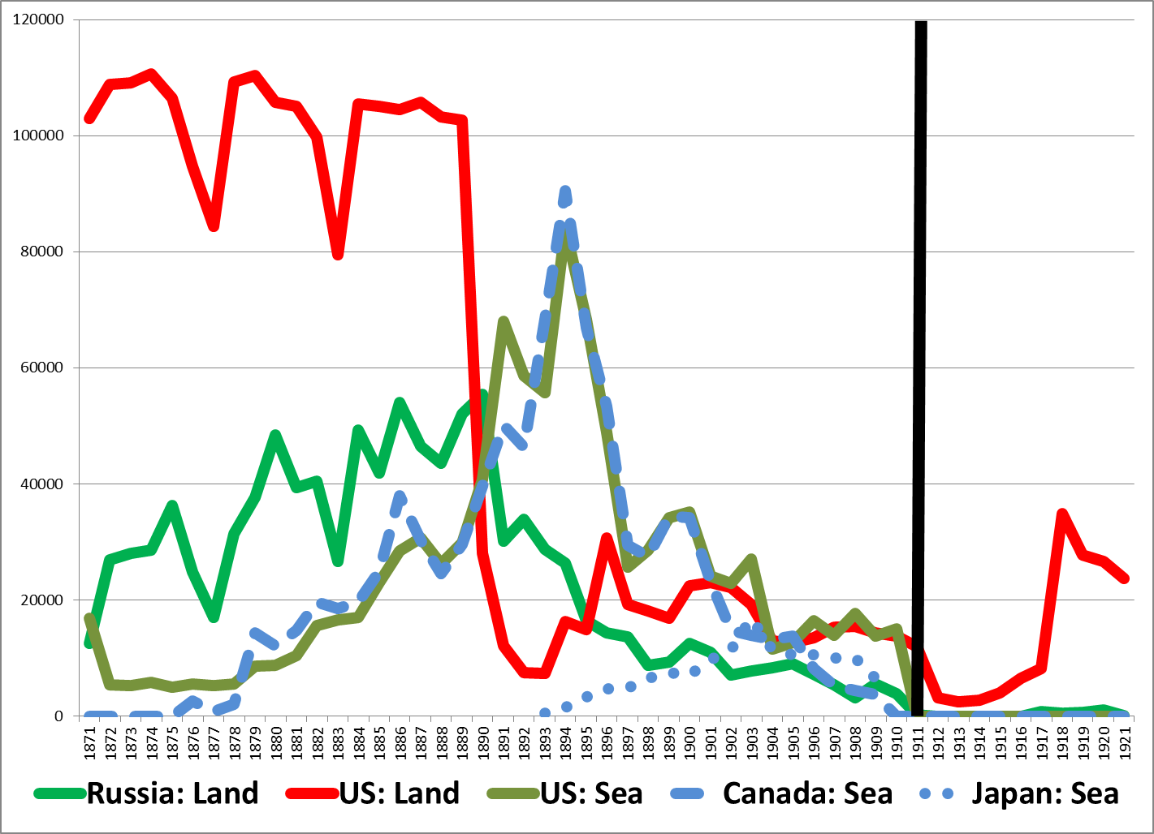

Fisheries example: Convention for the Conservation of Salmon in the North Atlantic Ocean (NASCO) Example

Course takehomes:

Two different BASES to estimate counterfactual of what members would have done if they had NOT been members

Generating SAME counterfactual but doing it on a different basis

We observe: catch by NASCO members of salmon in the North Atlantic after 1980 with treaty having taken effect

To estimate treaty effect, we want: unobservable catch by NASCO members of salmon in the North Atlantic after 1980 had treaty NOT taken effect

How many counterfactuals can we generate for it that we can use to estimate its effect?

Members, salmon, North Atlantic, before 1980

Non-members, salmon, North Atlantic, after 1980

Members, salmon, SOUTH Atlantic, after 1980

Members, NON-salmon, North Atlantic, after 1980

Comparing two examples

Whaling example

Course takehomes:

Always two possible measures of effectiveness

Goal Achievement

Counterfactual

Can Succeed on Counterfactual and Fail on Goal Achievement
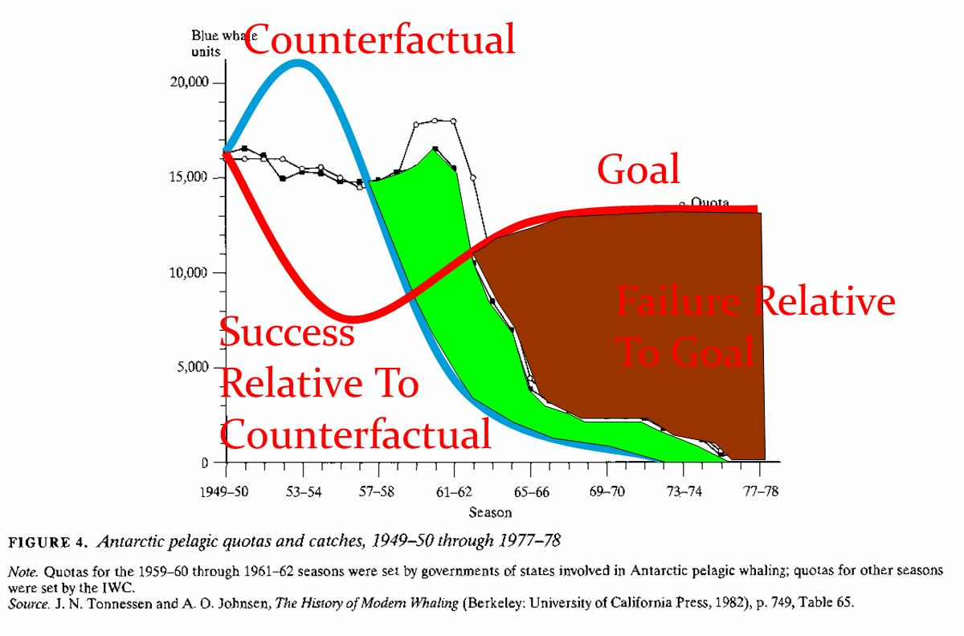

Montreal Protocol example

Course takehomes:

Counterfactual based on comparing different regulation of members, not membership vs. non-membership

Effective institutional design improved over time

Consider comparing the Montreal Protocol and Whaling regimes

How do the structures of the problems that the Montreal Protocol and Whaling regimes are facing differ?

How do the features of the Montreal Protocol and Whaling regimes (i.e., their regime type) differ?

Which has been more effective at achieving its goals?

What was the relative difficulty of the tasks the two regimes faced?

In evaluating the relative effectiveness of these two conventions, which regimes accomplishments strike you as more impressive?

If you see one regime as more effective than the other, to what do you attribute its success?

How do we distinguish "effects of the treaty" from "changes in the thing the treaty was trying to effect"?

If they were equally effective or ineffective, to what do you attribute the similarity in these outcomes?

Climate change

Course takehomes: Problem structure may make it really hard to solve a problem, especially if countries unwilling

Conclusions

How do we evaluate the effects of a treaty on behavior?

How do we account for differences in problem structure?

How do we account for differences in regime design and features?

This is a lot to cover in a short time but provides a background for thinking about how to do the analysis of this course.

